COURSE NAME:Theory of Computation COURSE CODE: CSA1310

COURSE OUTCOME COVERED
Criteria | Weightage |  | Q1 (25) |  | Q2 (25) | Total Marks  (50)
Conceptual  Understanding | 30% |  | 7.5 |  | 7.5 | 15
Accuracy of Answer | 25% |  | 6.25 |  | 6.25 | 12.5
Application of  Knowledge | 20% |  | 5 |  | 5 | 10
Completeness of  Response | 15% |  | 3.75 |  | 3.75 | 7.5
Clarity &  Presentation | 10% |  | 2.5 |  | 2.5 | 5
Total per Question | 100% | 25 |  | 25 |  | 50
CO1: Apply mathematical foundations such as formal proofs, induction, and basic concepts of automata theory to solve computational problems. (BL:3)

Assessment Tool Weightage:20%

QUESTIONS: 2 Total Marks:50 Duration : 1 Hour

Simulation

Code of Conduct:
I am ch.ramakrishna(192372280) (Name / Reg No) certify that this submission is my original work and that I have adhered to the guidelines specified for this assessment.
I understand that any violation of academic integrity rules will result in disciplinary action.
Signature of the student:
- Design a Non-Deterministic Finite Automaton (NBA) for an Automatic Door System based on sensor inputs.An automatic door system can be modeled using an NBA to represent different states and transitions. The system consists of four states: Closed, Opening, Open, and Closing. The input symbols are P (Person detected) and N (No person detected). Initially, the door is in the Closed state. When a person is detected (P), the system may non-deterministically transition from Closed to Opening. Once opened, the system moves to the Open state. If no person is detected (N), the door transitions to Closing and eventually returns to the Closed state. Non-determinism occurs when the system may remain in the Open state even if a person is detected or may start closing if no detection occurs.
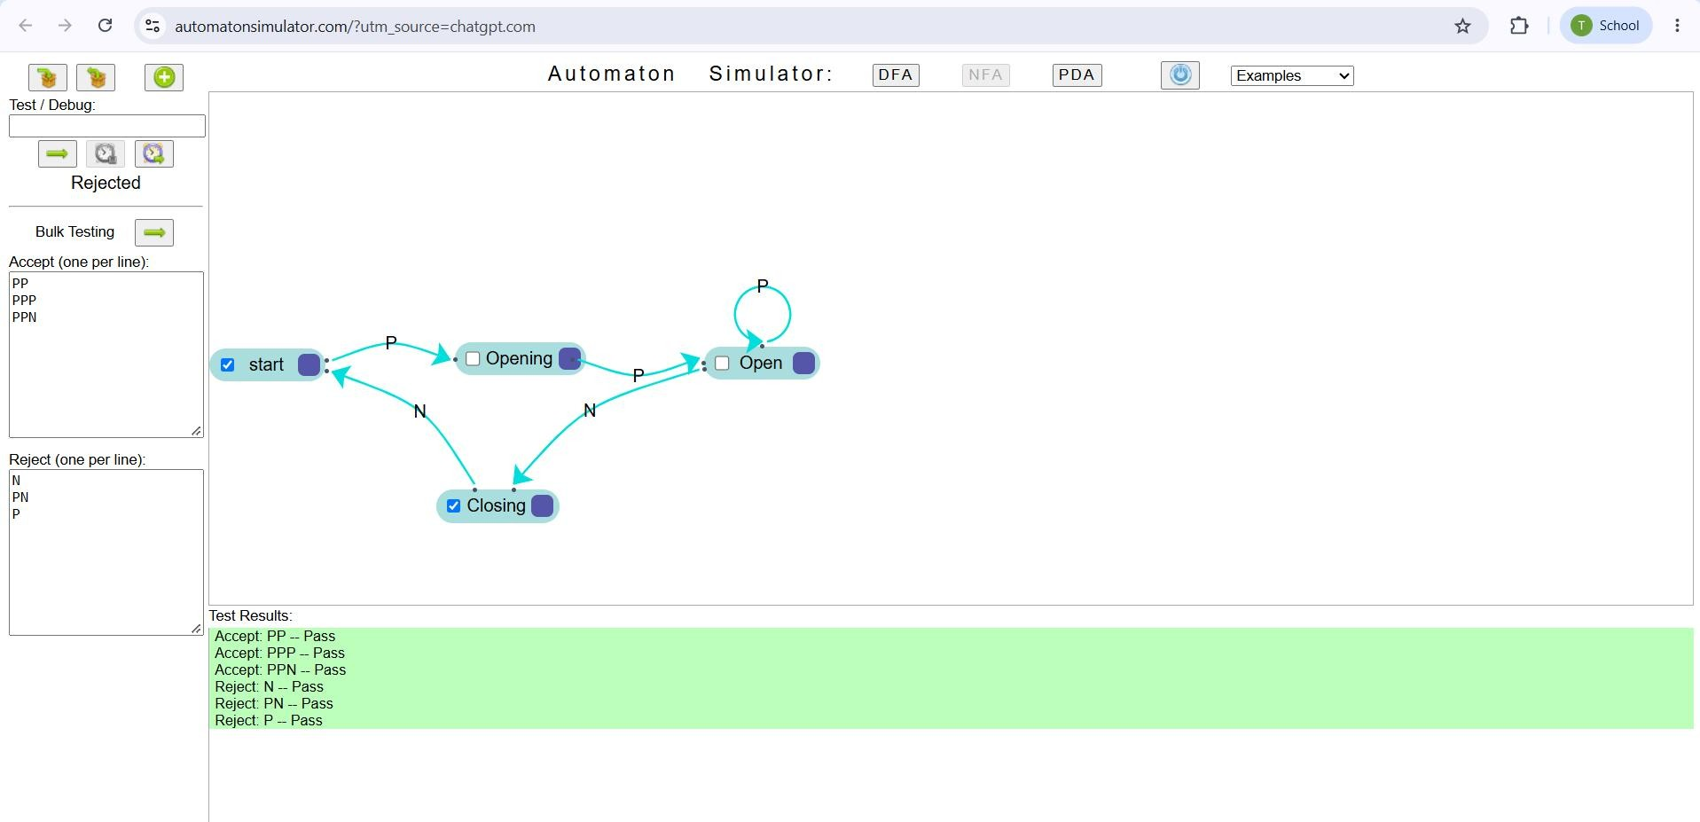
- Design a finite automaton to model a traffic light control system at a road intersection. The automaton should represent different states corresponding to the traffic lights, such as Red, Green, and Yellow. Define the transitions between these states based on a timer or control signals, ensuring that the sequence follows the standard order (Red → Green → Yellow → Red). Include considerations for timing constraints, such as how long each light remains active, and describe how the automaton handles continuous cycling of signals. Additionally, explain how this model can be extended to handle pedestrian crossing signals or emergency vehicle overrides, ensuring safe and efficient traffic flow
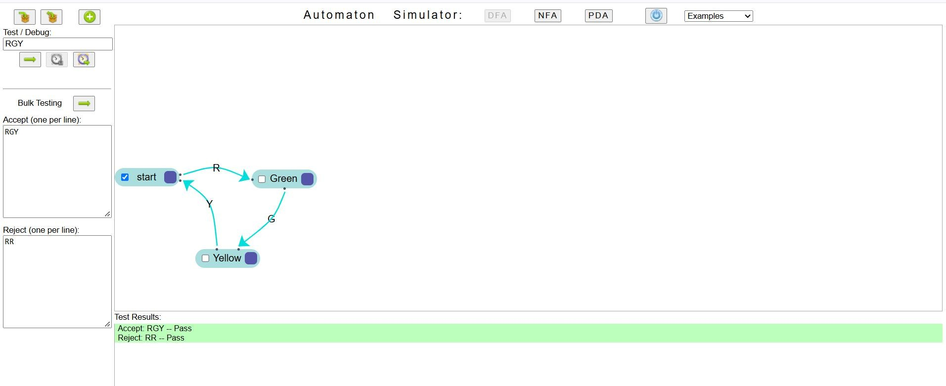

RUBRICS FOR CALCULATION
100

